What is Serialization?
Serialization is the process of bringing an object into a form that it can be written on stream.
It's the process of converting the object into a form so that it can be stored on a file, database, or memory; or, it can be transferred across the network.
Its main purpose is to save the state of the object so that it can be recreated when needed.

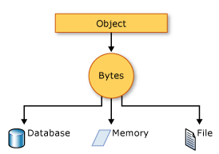

What is Deserialization?
As the name suggests, deserialization is the reverse process of serialization.
It is the process of getting back the serialized object so that it can be loaded into memory.

Types
- Binary Serialization
- XML Serialization
- JSON Serialization
First, we go and import the name space for serialization.

using System.Runtime.Serialization;

Then Import the formatter

using System.Runtime.Serialization.Formatters.Binary;

Convert "customer obj" to binary. Also, need the "using System.IO;"create the file or read to file.
Most important, go and mark the "class" [Serializable]

Advantages of serialization -

- Passing an object from one application to another.
- Passing an object from one domain to another.

